Objectives:

* Inheritance, super class, sub class, images, setting width and height of frames
* **3 class exercises on this document each worth 33.3%**

**Inheritance** allows a new class to extend an existing class. The new class inherits the members of the class it extends. The **subclass** is an extended version of the **superclass**. The **subclass** inherits fields and methods may be added to the subclass.

* **subclass** (child) - the class that inherits from another class
* **superclass** (parent) - the class being inherited from
* To inherit from a class, using the *extends* keyword

**Project #1**

Create a class **Employee** and type in the following code: This is an example of **Single Level Inheritance**, with only 2 classes

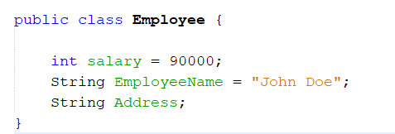

1. Now, we will create a class named **Company** and extend the **Employee** Class

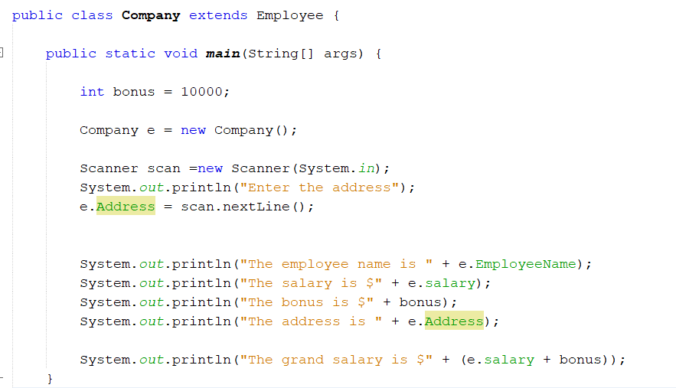

**Challenge Exercise #1:** add to project #1, city, state, zip code and age.

**#1 print screen the output with code below here.**

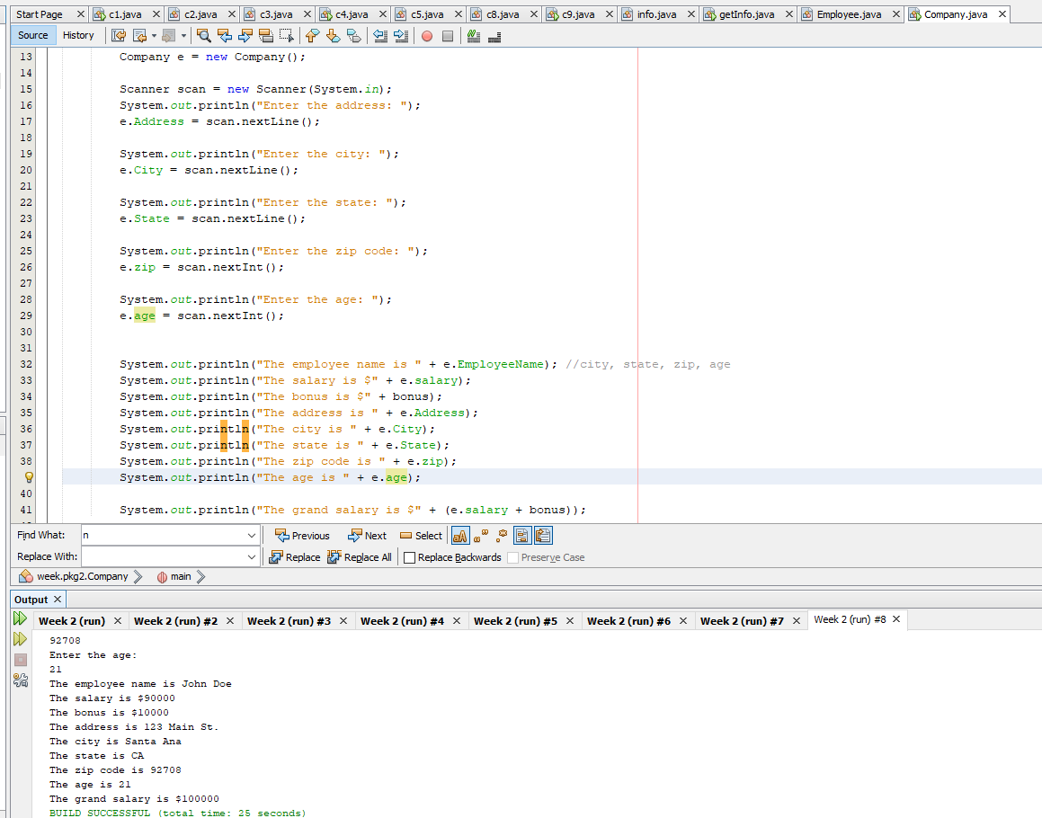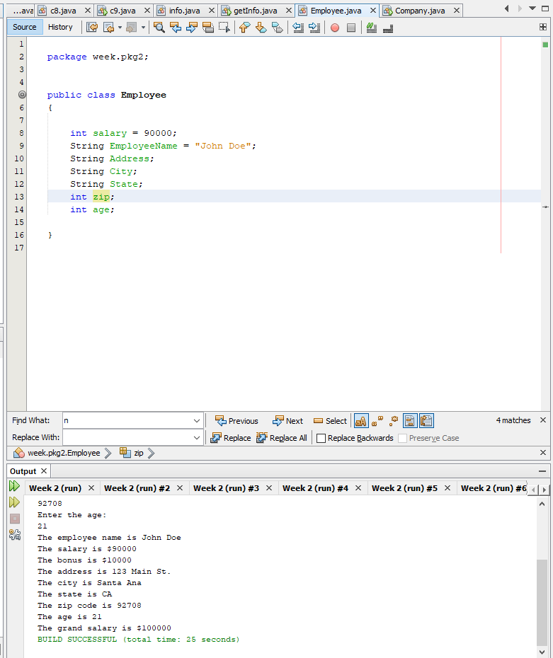

**Project #2**

Create a class **Vehicle** and type in the following code: This is an example of **Single Level Inheritance**, with only 2 classes

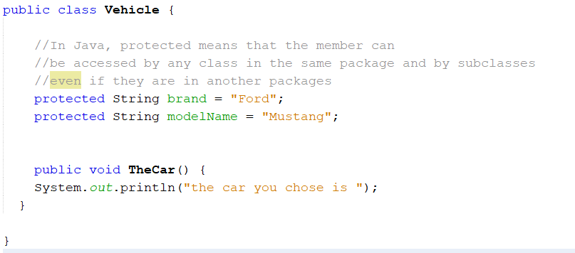

1. Create a class **Car** and extend the Vehicle class

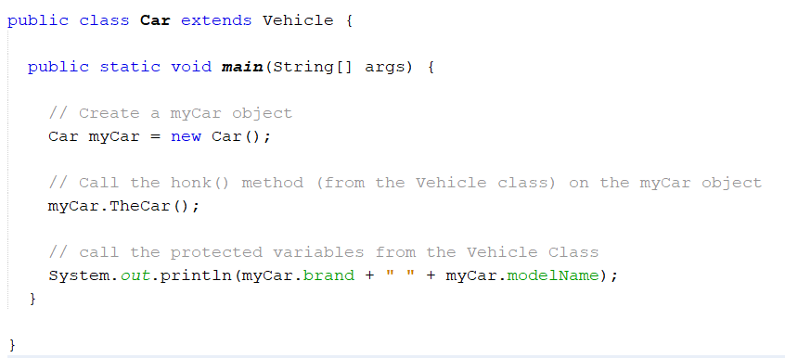

**Project #3**

Create a class **Grades** and type in the following code (there is no main method).

Declaring score as a variable

Creating a method setScore and passing 1 argument and setting the score variable the s argument

The method getScore returns the variable score

The getGrade method returns the scores

Create a class **RunGrades** and type in the following code (we will create the main method)

**Challenge Exercise #2**: get the average of the two numbers, be sure to use the sub class to create additional methods.

**#2 print screen the output with code below here**

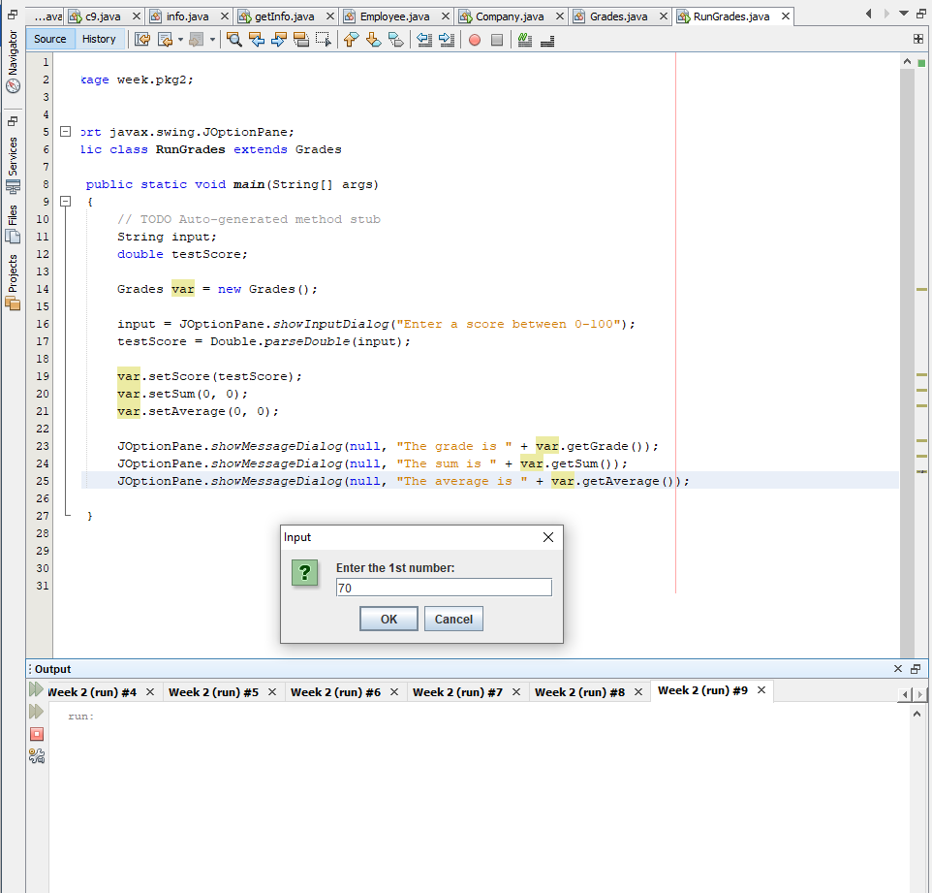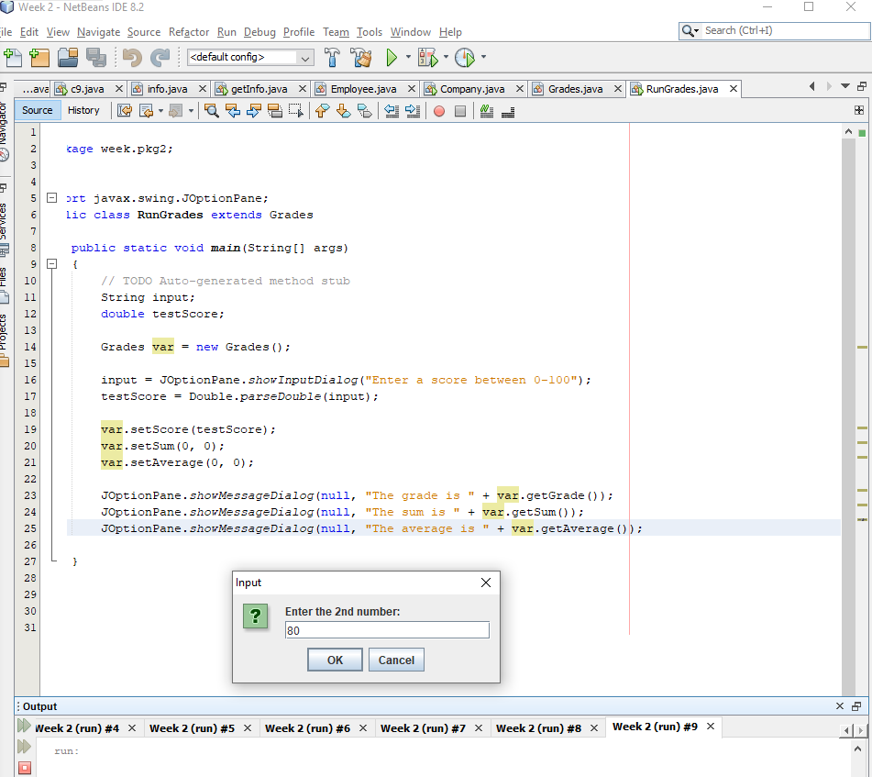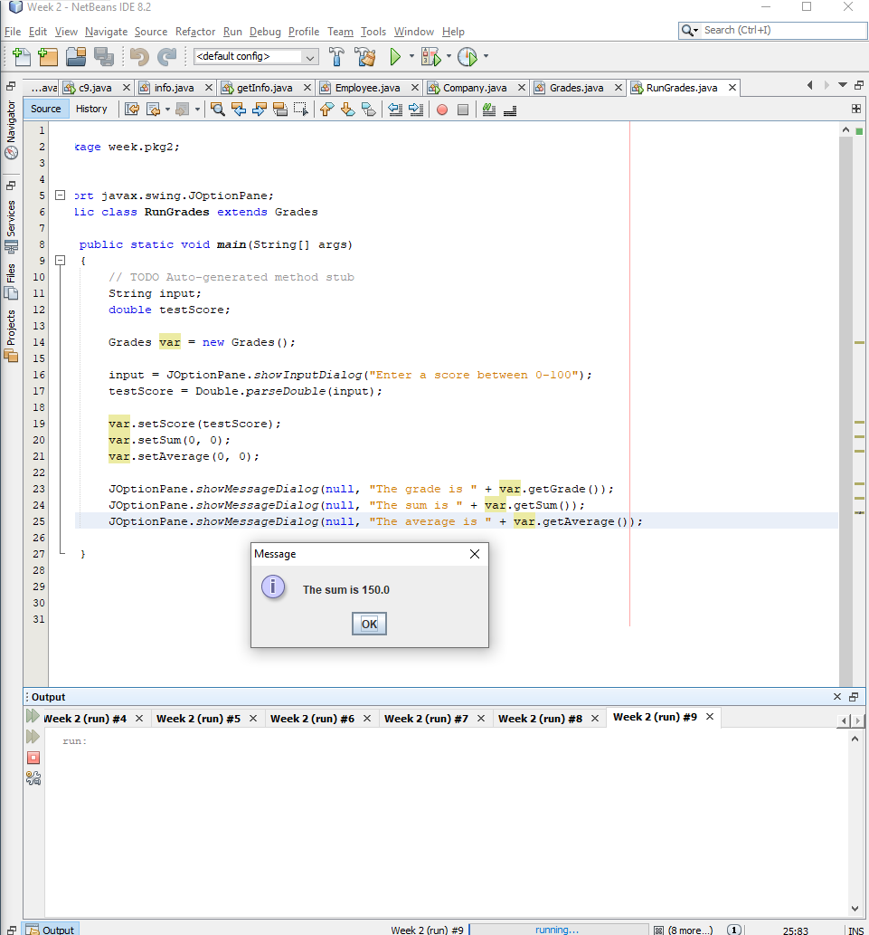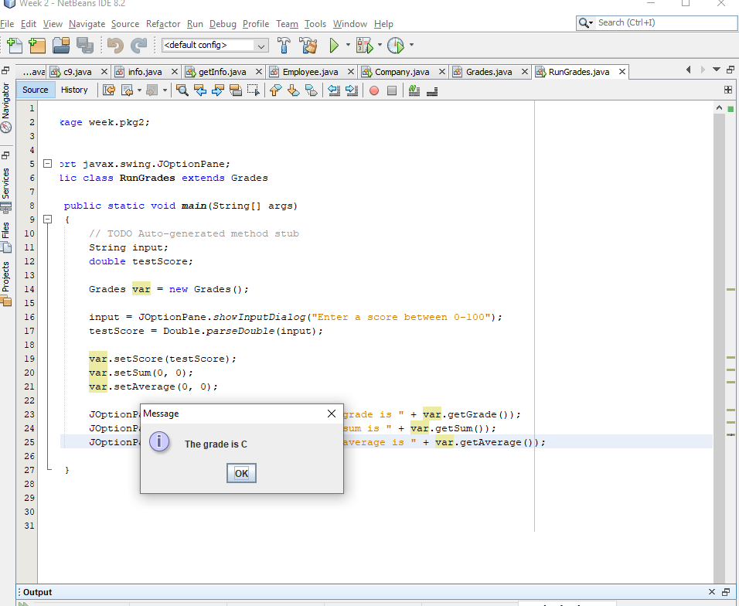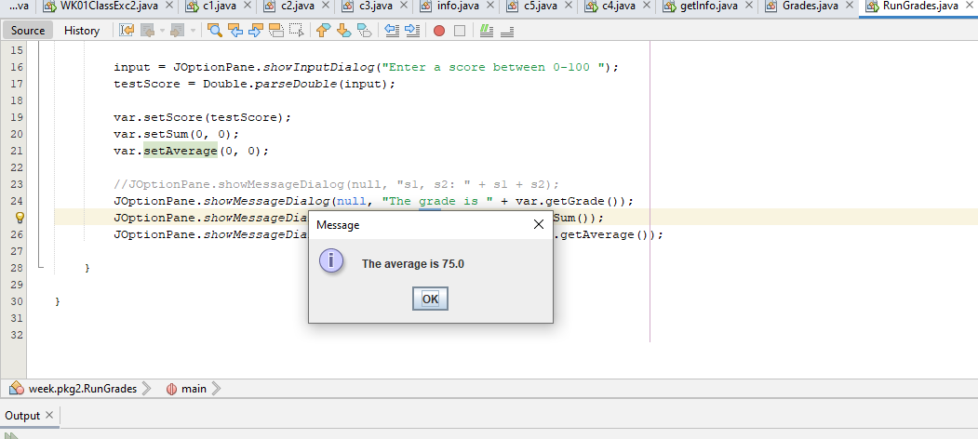

**Project #4**

1. Create a class Bicycle

c

Create a class Mountain Bike that will extend Bicycle

Create the main method

**Challenge Exercise #3:** include a scanner so it will ask the user questions

**#3 print screen the output with code below here.**

**Bicycle:**

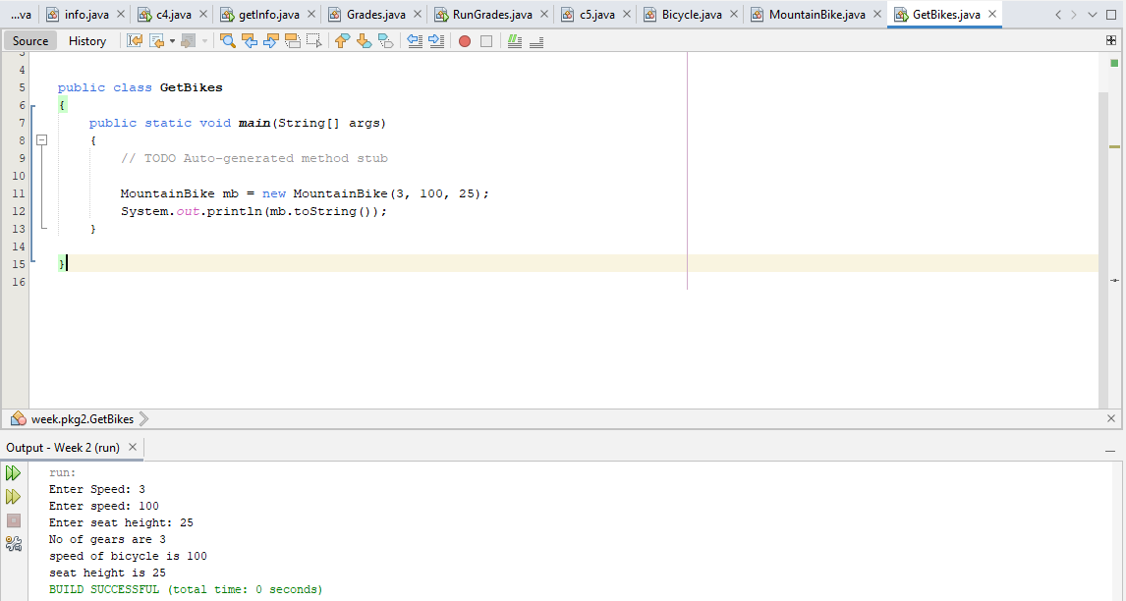

**Submit this document to Module 2 class exercise**